CS 255 Business Requirements Document Template

Complete this template by replacing the bracketed text with the relevant information.

This template lays out all the different sections that you need to complete for Project One. Each section has guiding questions to prompt your thinking. These questions are meant to guide your initial responses to each area. You are encouraged to go beyond these questions using what you have learned in your readings. You will need to continually reference the interview transcript as you work to make sure that you are addressing your client’s needs. There is no required length for the final document. Instead, the goal is to complete each section based on your client’s needs.

Tip: You should respond in a bulleted list for each section. This will make your thoughts easier to reference when you move into the design phase for Project Two. One starter bullet has been provided for you in each section, but you will need to add more.

System Components and Design

Purpose
What is the purpose of this project? Who is the client and what do they want their system to be able to do?

- The client is DriverPass, a company that wants to provide better training for students preparing for DMV driving exams.
- The purpose of the project is to design a cloud-based, web-accessible system that supports online classes, practice tests, driving lesson scheduling, customer registration, reports, and account management.
- The system should allow customers and employees to access the services they need from computers and mobile devices.
- The system should improve DriverPass operations by keeping customer, appointment, driver, vehicle, and training information organized in one central system.

System Background
What does DriverPass want the system to do? What is the problem they want to fix? What are the different components needed for this system?

- DriverPass identified a problem in which many students fail their DMV examinations because they rely mainly on old practice tests and do not receive enough complete driver training.
- DriverPass wants to solve this problem by offering online practice exams, online course materials, in-person instruction, and behind-the-wheel driving lessons.
- The system will support customers, the secretary, driving instructors, the owner, and the IT administrator.
- Customers will be able to create accounts, purchase training packages, schedule two-hour driving sessions, take practice tests, and monitor their progress.
- The secretary will be able to register customers and schedule, modify, or cancel appointments on their behalf.
- The system will track the customer, driver, vehicle, lesson time, pickup location, drop-off location, and appointment status.
- The system will receive updates from the DMV when rules, policies, or sample questions change.
- The system will include reporting, activity tracking, customer records, practice-test results, driver notes, and cloud-based data storage.

Objectives and Goals
What should this system be able to do when it is completed? What measurable tasks need to be included in the system design to achieve this?

- The system should allow customers to register and create secure accounts.
- The system shall allow customers and the secretary to schedule, modify, and cancel driving lessons.
- The system should assign an available driver and vehicle to every driving appointment.
- The system should support three training packages and allow an authorized employee to disable a package.
- The system should provide online classes and practice exams to eligible customers.
- The system shall record each practice test’s name, completion time, score, and status.
- The system shall record lesson dates, start times, end times, and driver comments.
- The system shall record who created, modified, or canceled each reservation.
- The system shall allow authorized users to generate and download activity and management reports.
- The system should notify DriverPass when the DMV publishes updated rules, policies, or practice questions.
- The system shall support secure access from computers and mobile devices.
- The system shall allow customers to automatically reset forgotten passwords.

Requirements

Nonfunctional Requirements
In this section, you will detail the different nonfunctional requirements for the DriverPass system. You will need to think about the different things that the system needs to function properly.

Performance Requirements
What environments (web-based, application, etc.) does this system need to run in? How fast should the system run? How often should the system be updated?

- The system shall operate as a web-based application hosted in a cloud environment.
- The system shall be available to authorized users from computers and mobile devices with internet access.
- The system shall respond quickly enough that login, scheduling, report generation, and practice-test pages do not cause unreasonable delays.
- The system shall support multiple users working at the same time without significant loss of performance.
- The system shall update appointment, account, test, and customer information immediately after authorized changes are saved.
- The system shall receive DMV content updates whenever the DMV provides new rules, policies, or sample questions.
- The system shall allow reports and selected information to be downloaded in a format compatible with Excel.

Platform Constraints
What platforms (Windows, Unix, etc.) should the system run on? Does the back end require any tools, such as a database, to support this application?

- The system shall run through modern web browsers rather than requiring a separate desktop installation.
- The interface shall support computers, tablets, and mobile devices.
- The backend shall use a centralized cloud-hosted database to prevent duplicate or conflicting records.
- Users shall need an internet connection to create, modify, or update system data.
- The system shall depend on a reliable connection to the DMV for external content updates.
- The design shall use technologies that support secure cloud hosting, database storage, backups, and future maintenance.

Accuracy and Precision
How will you distinguish between different users? Is the input case-sensitive? When should the system inform the admin of a problem?

- Every user shall have a unique account and assigned role.
- The system shall distinguish among customers, the secretary, instructors, the owner, and the IT administrator.
- Usernames and passwords shall be validated exactly as entered, including any required case sensitivity.
- The system shall prevent conflicting appointments involving the same customer, driver, vehicle, or time period.
- The system shall verify that pickup and drop-off information is recorded for each driving lesson.
- The system shall accurately calculate the number of two-hour sessions included in each training package.
- The system shall maintain an audit record showing who created, changed, or canceled an appointment.
- The system shall notify the administrator when account, database, security, or synchronization errors occur.

Adaptability
Can you make changes to the user (add/remove/modify) without changing code? How will the system adapt to platform updates? What type of access does the IT admin need?

- Authorized users shall be able to add, modify, disable, or remove user accounts without changing the source code.
- The IT administrator shall have full access to maintain the system, reset passwords, block accounts, and manage user permissions.
- The owner or another authorized employee shall be able to disable a training package so new customers cannot register for it.
- The system shall support future operating-system, browser, database, and cloud-platform updates.
- The system design shall allow future features or training packages to be added with limited changes to existing components.
- Customer information, appointment records, and system settings shall be editable through authorized interfaces instead of requiring code changes.

Security
What is required for the user to log in? How can you secure the connection or the data exchange between the client and the server? What should happen to the account if there is a “brute force” hacking attempt? What happens if the user forgets their password?

- Every user shall log in with a unique username and password.
- The system shall use role-based access so users can only view or change information allowed for their role.
- All data exchanged between users and the server shall be encrypted through HTTPS.
- Passwords shall be stored securely and shall not be saved in plain text.
- Sensitive customer and payment information shall be protected from unauthorized access.
- The system shall temporarily lock or restrict an account after repeated failed login attempts.
- The system shall record failed login attempts and notify the IT administrator when suspicious activity occurs.
- Customers shall be able to use a secure automatic password-reset process.
- The IT administrator shall be able to manually reset passwords and disable former employee accounts.
- The cloud environment shall provide secure backups and recovery of system data.

Functional Requirements
Using the information from the scenario, think about the different functions the system needs to provide. Each of your bullets should start with “The system shall . . .” For example, one functional requirement might be, “The system shall validate user credentials when logging in.”

- The system shall validate user credentials when a user logs in.
- The system shall allow customers to create an account.
- The system shall allow customers and secretaries to enter and update customer information.
- The system shall store the customer’s name, address, telephone number, state, pickup location, and drop-off location.
- The system shall allow customers to select an available training package.
- The system shall allow authorized employees to disable a training package.
- The system shall allow customers and secretaries to schedule driving lessons.
- The system shall allow customers and secretaries to modify or cancel appointments.
- The system shall assign an available driver and vehicle to each driving lesson.
- The system shall prevent scheduling conflicts involving customers, drivers, vehicles, and lesson times.
- The system shall provide online course materials and practice tests.
- The system shall display test name, time taken, score, and status.
- The system shall record test statuses as not taken, in progress, failed, or passed.
- The system shall display lesson dates, start times, end times, and driver comments.
- The system shall maintain an order and payment record for each customer package.
- The system shall allow customers to reset forgotten passwords.
- The system shall allow the IT administrator to reset passwords, manage accounts, and block user access.
- The system shall record who created, modified, or canceled each reservation.
- The system shall generate printable activity and management reports.
- The system shall allow selected reports to be downloaded for use in Excel.
- The system shall receive and store DMV updates to rules, policies, and sample questions.
- The system shall notify authorized employees when DMV updates become available.
- The system shall provide a contact page and a method for DriverPass employees to contact students.

User Interface
What are the needs of the interface? Who are the different users for this interface? What will each user need to be able to do through the interface? How will the user interact with the interface (mobile, browser, etc.)?

- The system shall provide a clear, consistent, web-based interface that works on desktop and mobile devices.
- The login page shall allow users to enter credentials and access features based on their assigned role.
- Customers shall be able to register, update profiles, select packages, schedule lessons, cancel or modify appointments, take practice tests, and review progress.
- The secretary shall be able to register customers and create, modify, or cancel appointments for them.
- Driving instructors shall be able to view assigned lessons and enter lesson notes.
- The owner shall be able to view reports, customer activity, appointments, and business information.
- The IT administrator shall be able to manage accounts, permissions, passwords, and system maintenance.
- The customer dashboard shall display practice-test progress, including test name, time, score, and status.
- The customer dashboard shall display lesson information, including date, start time, end time, and driver comments.
- Forms shall use clear labels and validation messages to help users enter information correctly.
- The interface shall include confirmation messages after registration, appointment changes, cancellations, and password resets.
- The interface shall include a contact page and a way to communicate with students.

Assumptions
What things were not specifically addressed in your design above? What assumptions are you making in your design about the users or the technology they have?

- Users will have reliable internet access when viewing or changing system information.
- Customers will have access to a computer, tablet, or mobile device with a modern web browser.
- Customers will provide accurate contact, payment, pickup, and drop-off information.
- Customers will have valid email addresses or another approved method for receiving notifications.
- DriverPass employees will receive training on their roles and system functions.
- The DMV will continue to provide updated rules, policies, and practice-test information in a usable electronic format.
- The selected cloud provider will supply reliable hosting, backups, and security services.
- Drivers and vehicles will be available according to the schedules entered into the system.

Limitations
Any system you build will naturally have limitations. What limitations do you see in your system design? What limitations do you have as far as resources, time, budget, or technology?
- The system will require internet access for users to create, modify, or synchronize information.
- The first release will not allow nontechnical employees to create completely new system modules.
- Adding new package structures or major features may require assistance from a developer or systems analyst.
- The system will depend on the availability and format of information supplied by the DMV.
- The system will depend on third-party cloud, payment, email, and internet services.
- Project scope, budget, staffing, and schedule may limit the number of features included in the first release.
- The system cannot prevent users from providing incorrect personal or scheduling information.
- Temporary outages involving the cloud provider, internet service, DMV connection, or payment provider may interrupt some functions.

Gantt Chart
Please include a screenshot of the GANTT chart that you created with Lucidchart. Be sure to check that it meets the plan described by the characters in the interview.

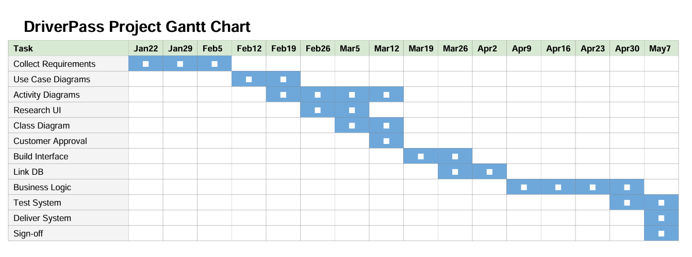

References
Southern New Hampshire University. (n.d.). DriverPass interview transcript. CS 255: System Analysis and Design course resource.

